Home Safety Tips

comprehensive children’s injury center

Preventing Falls
- Properly install window guards and stops to prevent window falls. Windows above the first floor should have an emergency release device in case of fire.
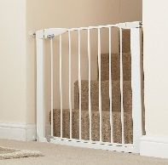
- Safety gates can be used to keep kids away from stairs and out of rooms with hazards.
- Make sure kids do not play on furniture or on stairs.
- Anti-slip mats can be used in bathtubs and other slippery areas.

Poison Prevention
- Store all cleaning products and chemicals up high or secure the cabinet with a lock.
- Keep alcohol, tobacco, and e-cigarette products out of reach of kids.
- Candy and medicine often look alike. Secure medicines and vitamins at home and wherever the child may be visiting.
- Put the toll-free Poison Help Number into your phone in case of emergency: 1-800-222-1222. Put a magnet or note on the refrigerator with emergency contact numbers for babysitters or caregivers.
- Laundry detergent pods are extremely poisonous if ingested by kids. Keep laundry pods and chemicals up high in sealed containers.
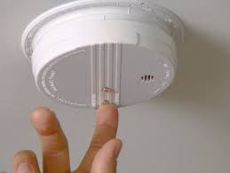
Fire & Burn Safety
- Install smoke alarms on every level of the home, especially near sleeping areas. Test smoke alarms twice per year at daylight savings time.
- Create and practice a fire escape plan and meeting place with your kids. Teach them once you get out, stay out!
- Keep lighters and matches out of kids reach. Only adults should light candles when they will be in the room where they are lit.
- Make sure paper, blankets, and other debris are away from the stove, space heaters, or candles.
- When cooking, turn all pot handles towards the back of the stove. Use back burners whenever possible.
- Make sure the microwave is out of reach of kids. They can easily open the microwave door and pull hot contents onto them.
- Set hot water heaters at 120 degrees or lower to prevent scald burns. If you can’t change the temperature, always use a thermometer to test bath water before bathing small children.
- Keep all styling tools away from children such as hairdryers, curling irons, and straighteners.
- Teach kids how and when to call 911.

Water Safety
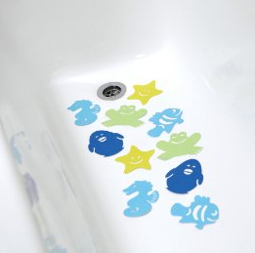
- Supervise kids during bath time. Avoid distractions of any kind such as reading or talking on the phone.
- Non-slip bath stickers are a great way to prevent slips and falls in the tub.
- Once bath time is over, immediately drain the tub. Keep toilet lids closed and keep doors to bathrooms closed if possible. It takes as little as 2 inches of water for a drowning to occur.
- Home or neighborhood pools should have fences at least 4 feet high with self-closing, self-latching gates to prevent a child from wandering into the pool unsupervised.

Gun Safety
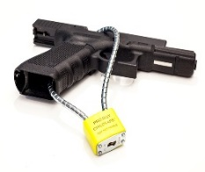
- Store guns and ammunition safely. Make sure all guns are equipped with effective, child-resistant gun locks.
- Do not leave guns on a nightstand, table, or other place where a child can gain easy access.
- Teach kids to never touch a gun and to immediately tell an adult if they see one.
- Remember, you may not have guns in your home, but a child could encounter one at a friend or relative’s house.

TV & Furniture Safety
- Push TVs, cable boxes, and DVD players back on the stand so they aren’t close to the edge.
- Mount TVs to the wall if possible to prevent tip overs.
- Anchor furniture so it doesn’t fall on the child. Bookshelves, dressers, and TV stands should be securely anchored to the wall.
- Never leave remotes or toys on top of TVs or tall furniture. The child may be tempted to climb to reach the object.
Safe Sleep
- Always follow the ABC’s of safe sleep.
  - Alone- Never sleep with a baby. Do not share sleeping spaces, even with siblings.
  - Back- Placing a baby to sleep on their back greatly reduces infant deaths.
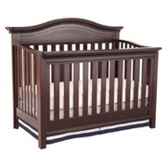
  - Crib- Use a firm mattress covered by a fitted sheet. Do not put a baby to sleep on a bed or couch. Keep pillows, stuffed animals, bumper padding, and other soft items out of the baby’s sleeping area.
- Refrain from using car seats, swings, or strollers for routine sleep.
- Pack-n-plays are a great alternative for babies to sleep safely.

Toy Safety
- Consider your child’s age when purchasing a game or toy. Make sure there aren’t small pieces or choking hazards.
- Discard broken toys so they do not become hazardous to children.
- Watch out for button batteries in toys, remotes, watches, etc. These small batteries can do serious internal damage if swallowed.
- Clean up toys so they do not become a trip hazard.

Vehicle Safety
- Make sure children are in age and weight appropriate child seats.
- Never allow children to play in or around vehicles.
- Double check that vehicles with push button engines are turned off while parked in the garage to prevent carbon monoxide poisoning in the home.
- Remember, you are your child’s role model in the vehicle. Kids are watching what their parents are doing in the car from an early age.

General Safety
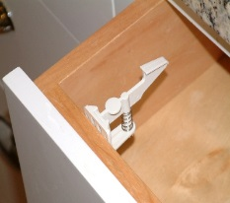
- Keep knives out of reach from children. Using a cabinet or drawer lock is a great way to secure knives.
- If your home was built before 1979, paint chips or dust from the paint could possibly contain lead. Have your home checked for lead paint and discuss lead concerns with your child’s doctor.
- Cover electrical outlets to reduce risk of electrocution. Plug covers can be used or furniture can be moved to block outlets.
- Blind cords should be beyond a child’s reach. Children can get tangled on window blind cords increasing the risk of strangulation.
- Avoid allowing children to play around sharp corners or edges. Corner covers are available for some furniture pieces.

